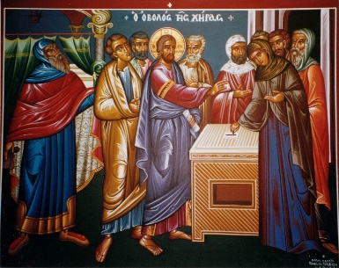
Holy Archangels 2024 Time, Talent, Treasure Pledge Form
Icon of the Widow giving her Offering, Mark 12:41-4

Name:
_____________________________________________________

Email: _______________________________________

Phone No.: ___________________________________

Address: _____________________________________________

Name’s Day___________________

I hereby pledge a biblical tithe (10% or more: Gen. 14; 28; Heb. 7:1) of my monthly income, to Holy Archangels as a “first fruit offering”. Amount: $__________

I hereby pledge as a step of faith as a partial tithe of ___% of my monthly income, to Holy Archangels. Amount: $___________

I hereby pledge to give $_______ monthly to Holy Archangels.

Important: Please make all checks payable to
Holy Archangels Orthodox Church.

“He who sows sparingly will also reap sparingly, and he who sows bountifully will also reap bountifully. ⁷ So let each one give as he purposes in his heart, not grudgingly or of necessity; for God loves a cheerful giver.” (II Cor. 9:6-7)
Holy Archangels 2024 Time, Talent, Treasure Pledge Form
Icon of the Widow giving her Offering, Mark 12:41-4

Name:
_____________________________________________________

Email: _______________________________________

Phone No.: ___________________________________

Address: _____________________________________________

Name’s Day___________________

I hereby pledge a biblical tithe (10% or more: Gen. 14; 28; Heb. 7:1) of my monthly income, to Holy Archangels as a “first fruit offering”. Amount: $__________

I hereby pledge as a step of faith as a partial tithe of ___% of my monthly income, to Holy Archangels. Amount: $___________

I hereby pledge to give $_______ monthly to Holy Archangels.

Important: Please make all checks payable to
Holy Archangels Orthodox Church.

“He who sows sparingly will also reap sparingly, and he who sows bountifully will also reap bountifully. ⁷ So let each one give as he purposes in his heart, not grudgingly or of necessity; for God loves a cheerful giver.” (II Cor. 9:6-7)

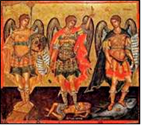
Time and Talent Pledge for Holy Archangels Orthodox Church, 2024

Please check all desired
- Prosphora Bakers: More prosphora bakers are needed to develop a reasonable rotation.
- Greeter: To greet visitors and members, hand out bulletins before Divine Liturgy and to present a welcoming face to all.
- Bookstore Volunteer: Help us do outreach to the community through our great bookstore while also helping provide for the church.
- Choir/Choir Director: Join the choir or, if able, offer your expertise by serving as a Choir Director. Please specify___________.
- Trapeza Supply/Organization: Volunteers are needed to organize trapeze/ coffee hours, supplies and to encourage participation.
- Fundraising: Help think and work creatively with others to help provide for the additional financial needs of Holy Archangels Mission.
- Altar Server: Serve with Fr. Robert at the altar and help provide for the liturgical needs of the church.
- Evangelism/Outreach: Help us reach those seeking Christ and His healing and salvation in their lives.
- Young Adults ministry: Work with Fr. Robert to better minister to our growing young adult population.
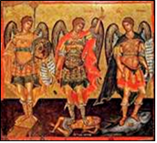
Time and Talent Pledge for Holy Archangels Orthodox Church,
2024

Please check all desired
- Prosphora Bakers: More prosphora bakers are needed to develop a reasonable rotation.
- Greeter: To greet visitors and members, hand out bulletins before Divine Liturgy and to present a welcoming face to all.
- Bookstore Volunteer: Help us do outreach to the community through our great bookstore while also helping provide for the church.
- Choir/Choir Director: Join the choir or, if able, offer your expertise by serving as a Choir Director.
- Trapeza Supply/Organization: Volunteers are needed to organize trapeze/ coffee hours, supplies and to encourage participation.
- Fundraising: Help think and work creatively with others to help provide for the additional financial needs of Holy Archangels Mission.
- Altar Server: Serve with Fr. Robert at the altar and help provide for the liturgical needs of the church.
- Evangelism/Outreach: Help us reach those seeking Christ and His healing and salvation in their lives.
- Young Adults ministry: Work with Fr. Robert to better minister to our growing young adult population.

