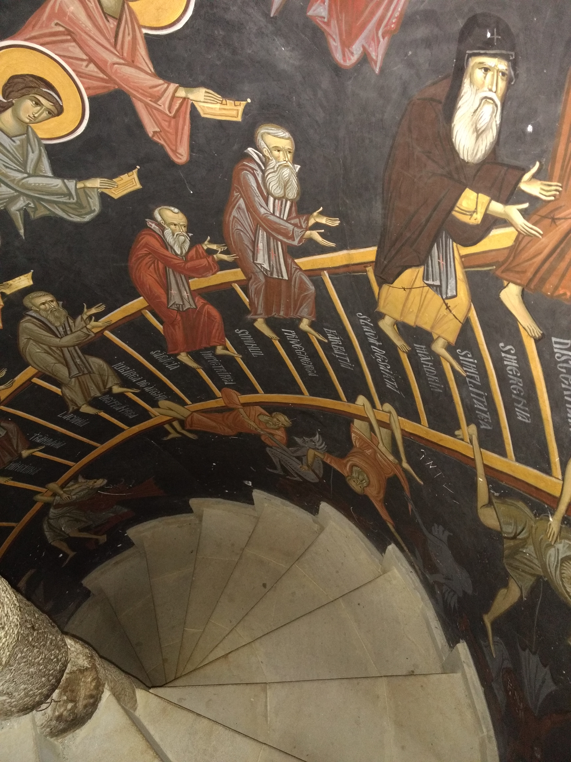
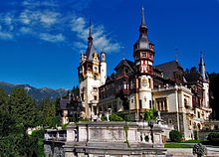
ROMANIA Pilgrimage
10-26 May 2022
“Spiritual Treasures
—of—
Orthodox Romania 5.0”
1: Peles Castle, Sinaia

When: 10-26 May 2022
2: Ladder of Divine Ascent, Pangarati Monastery, Moldova

What: A pilgrimage to Romania hosted by Holy Archangels Orthodox Church and led by Fr. Robert Miclean, an experienced pilgrimage guide. The pilgrimage is open to all Orthodox Christians, catechumens interested in Orthodox Christianity in Romania, visiting many of the holy sites, venerating the relics of the Saints, and being inspired by many of the important ministries, churches, and monasteries of Romania. Fr. Robert has ten years of experience leading pilgrimages and mission trips to Romania.

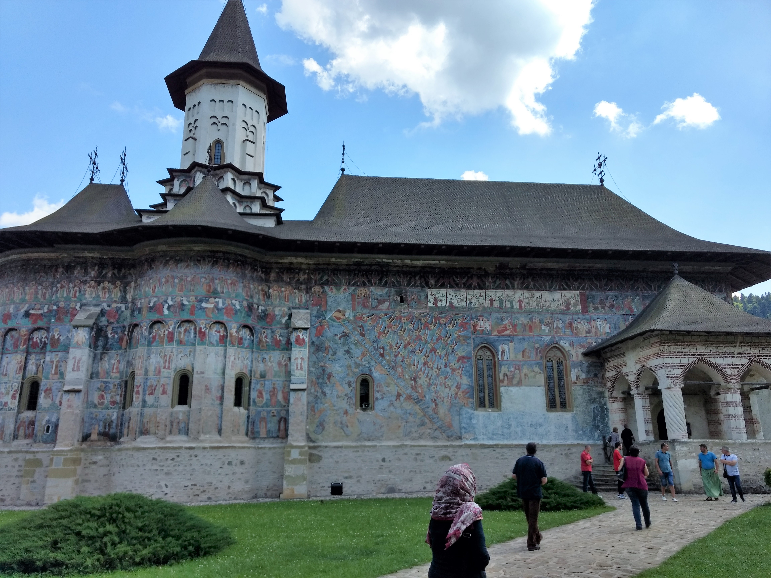
Where: We arrive in Bucharest, travel to the Pro Vita orphanage and ministry in Valea Plopului, visit the holy monastery of Crasna (‘beautiful’), nestled in the foothills of the Carpathian Mountains, visit the stunning town of Sinaia and Peleş Castle in the Alps, home to the Kings of Romania. From there we head North to Moldova and Bucovina to visit the holy monasteries of Petru Voda, resting place of Fr. George Calciu the Confessor, Sihăstrie, resting place of Elder Cleopa, Piatra Neamț, Agapia, home of St. Gheorghe the Pilgrim. We then visit the unique, painted and world-renowned monasteries of Bucovina: Putna, Voroneţ, Moldoviţa, Suceviţa, and Humor. We shop the outdoor markets at the painted monasteries, full of home-spun wares. We return to Bucharest for our final days, partake of the Feast of the Holy Emperors Constantine and Elena at the Patriarchal Cathedral, visit St. Nicholas (the ‘Russian’ church of the University, built by Czar Nicholas II), visit many important sites in the capital, including the Patriarchal Palace, the new Patriarchal Cathedral, St. George the New where we venerate St. Constantin Brâncoveanu and the right hand of St. Nicholas the Wonderworker. We venerate St. Spiridon in the church named after him, St. Antim Monastery, famous for the Burning Bush Movement (an Orthodox spiritual and anti-Communist movement which began there). Pilgrims will also have the opportunity to shop at some of the Patriarchal stores in Bucharest and at the holy monasteries throughout the trip.
3: The Painted Monasteries, Bucovina
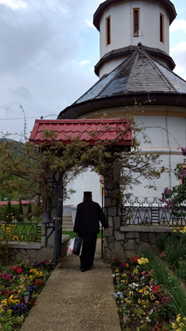
Why: To grow in our faith in Christ as we pray and venerate at many of Romania’s holy sites; to be edified by the rich heritage and beauty of Orthodox Christianity in Romania; to visit the children of the Pro Vita orphanage and ministry in Valea Plopului; to return strengthened in our Orthodox faith and life in Christ.

Program (subject to changes, as necessary)
- Tue., 10 May, Depart Dulles Int’l Airport (Note: departure date subject to 1 day change to Wed. 4 May, to secure best flights, travel accommodations)
- Arrive Bucharest, Wed., 4 May, Travel to ProVita, Valea Plopului.
- Thur., 12 May, Stay at Valea Plopului
- Sat., 14 May—Depart for the Crasna Monastery
- Sun., 15 May —Divine Liturgy at Crasna
- Mon., 16 May—Depart for Sinaia and Peleş Castle
- Tues., 17 May—Visit Peleş Castle, depart for Piatra Neamţ, stay at Presentation of Christ in the Temple Monastery, Piatra Neamț
- Wed., 18 May—Visit monasteries in the area: Pângărați, Bistriţa, Agapia, Văratec, overnight at Piatra Neamț
- Thurs., 19 May, depart for Petru Voda monastery (Fr. George Calciu, the Confessor, Archmandrite Iustin Parvu, both of blessed memory). Overnight at Piatra Neamț
6 Crasna Manastery
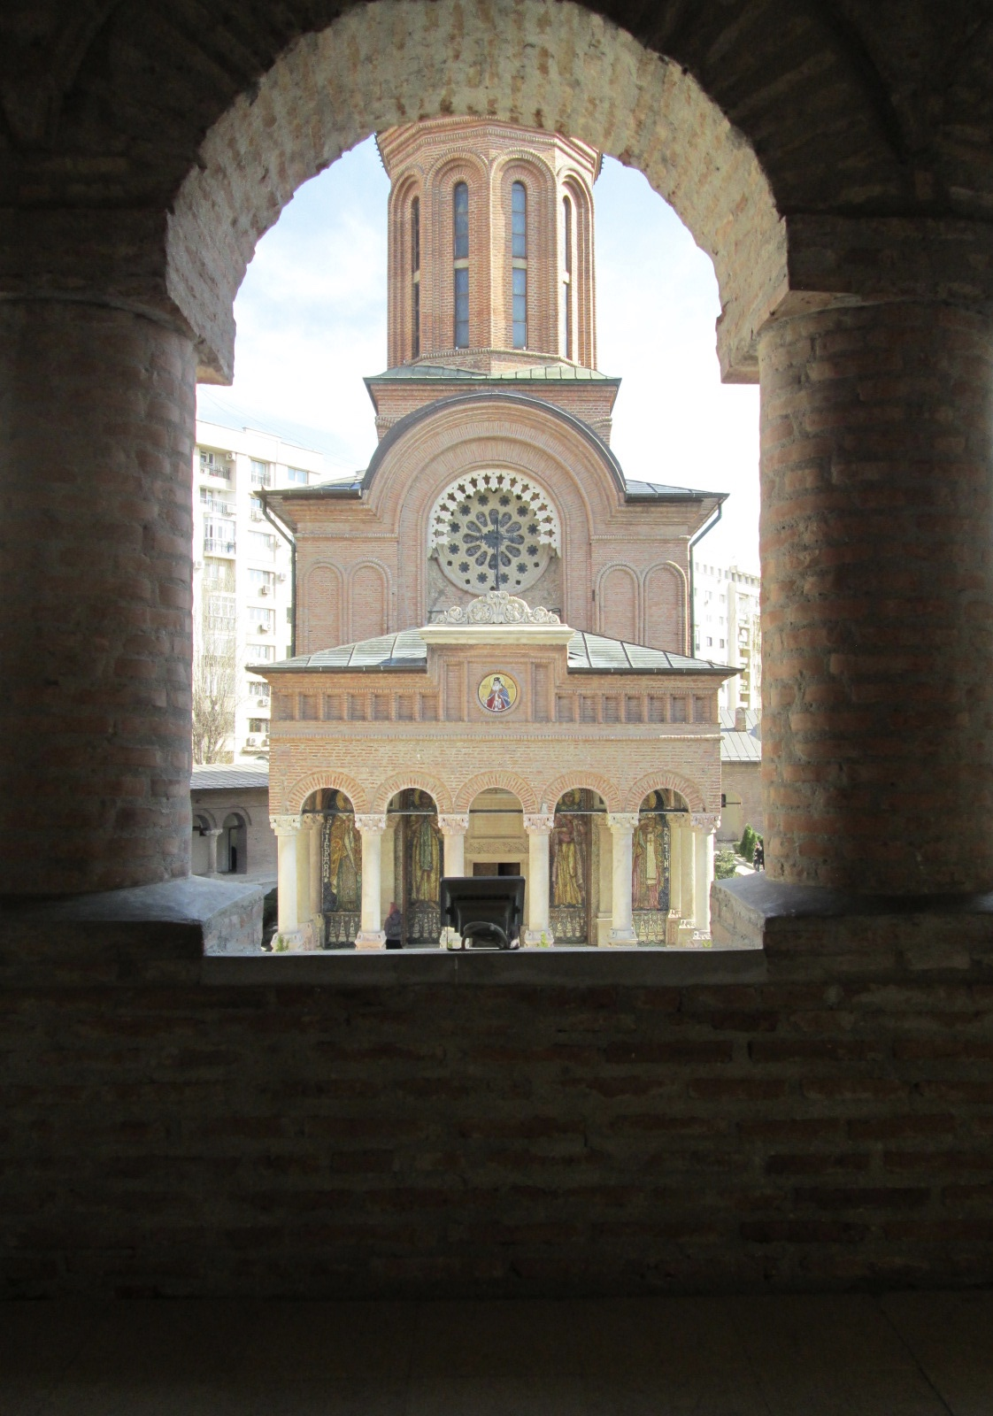
- Fri., 20 May, visit Sihăstriă Monastery (Elder Cleopa), painted monasteries (Putna, Voroneţ, Suceviţa, Moldoviţa), arrive and stay overnight at Putna Monastery
- Sat., 21 May, more painted monasteries of Bucovina, overnight at Putna
- Sun., 22 May, Divine Liturgy at Putna Monastery, remain overnight
- Mon., 23 May, a.m. Departure for Bucharest, overnight at Centru Social Sf. Andrei at Patriarchial Hill, 6 Hours + 2-3 stops
- Stay in Bucharest 23-26 May. While in Bucharest, we participate in the Patriarchal Patronal Feast of Ss Constantine and Elena, visit: Old Patriarchal Cathedral (relics of St. Dimitrie the New, St. Nectarius, SS Constantine and Elena), New Patriarchal Cathedral (Chapel/Paraclis relic—tooth of St. John Chrystostom, Biserica Rusă (St. Nicholas, ‘the Russian Church’, built by Czar Nicholas II), St. George the New (Right hand of St. Nicholas, St. Constantine Brâncoveanu), Radu Voda Monastery, where Fr. George Calciu of blessed memory preached his Seven ‘Words’ to the youth), St. Spiridon, Historic Monastery Antim (built by St. Antim, home of the “Burning Bush” movement), New Patriarchal Cathedral, Librării Sophia, Bizantina (Orthodox bookstores, icons)
4 Antim Monastery, Bucharest
- Thursday, 26 May, depart for Otopeni international airport for return flight to the USA.

