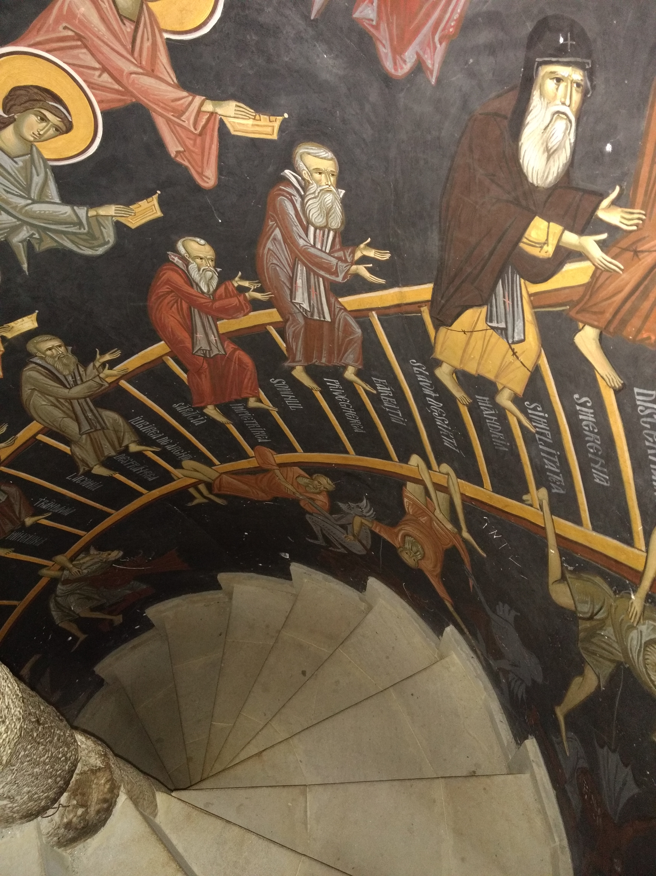  See first-hand what a ‘baptized’ culture can be, experience the continuity, warmth, and hospitality of the Orthodox faithful in dynamic, historic Romania—  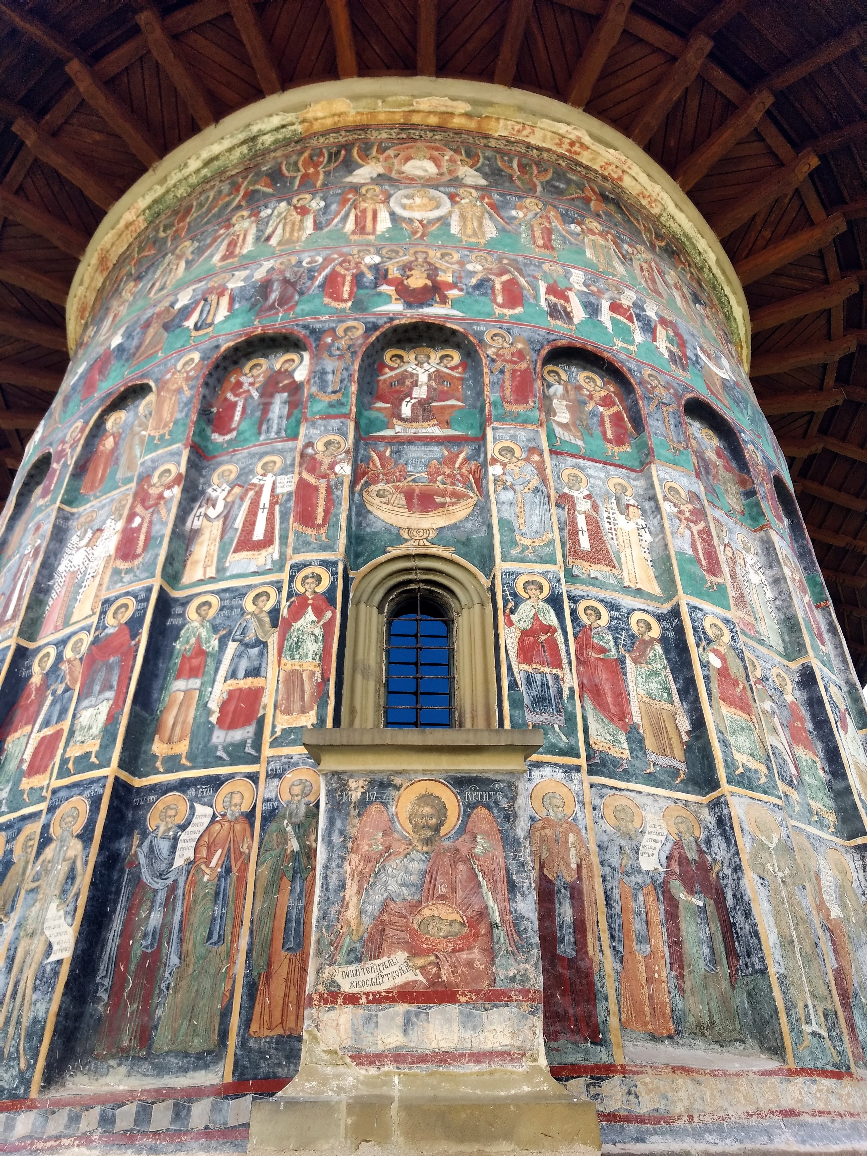 | 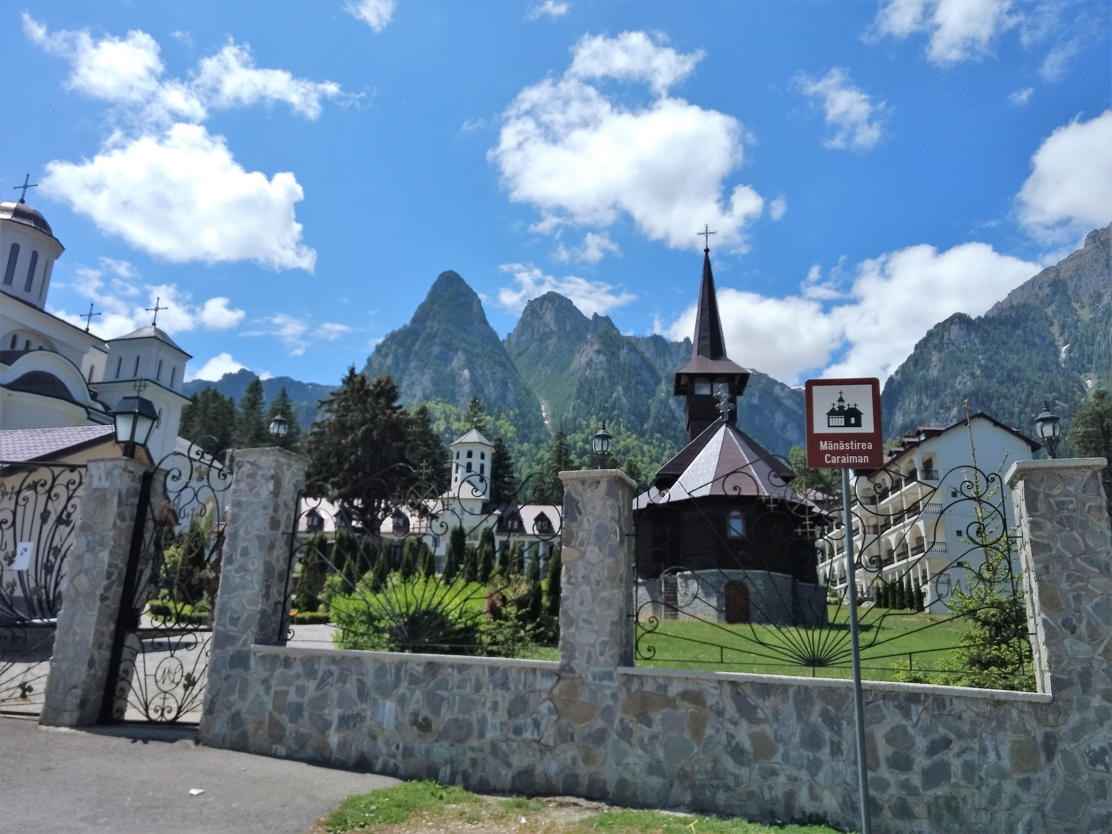  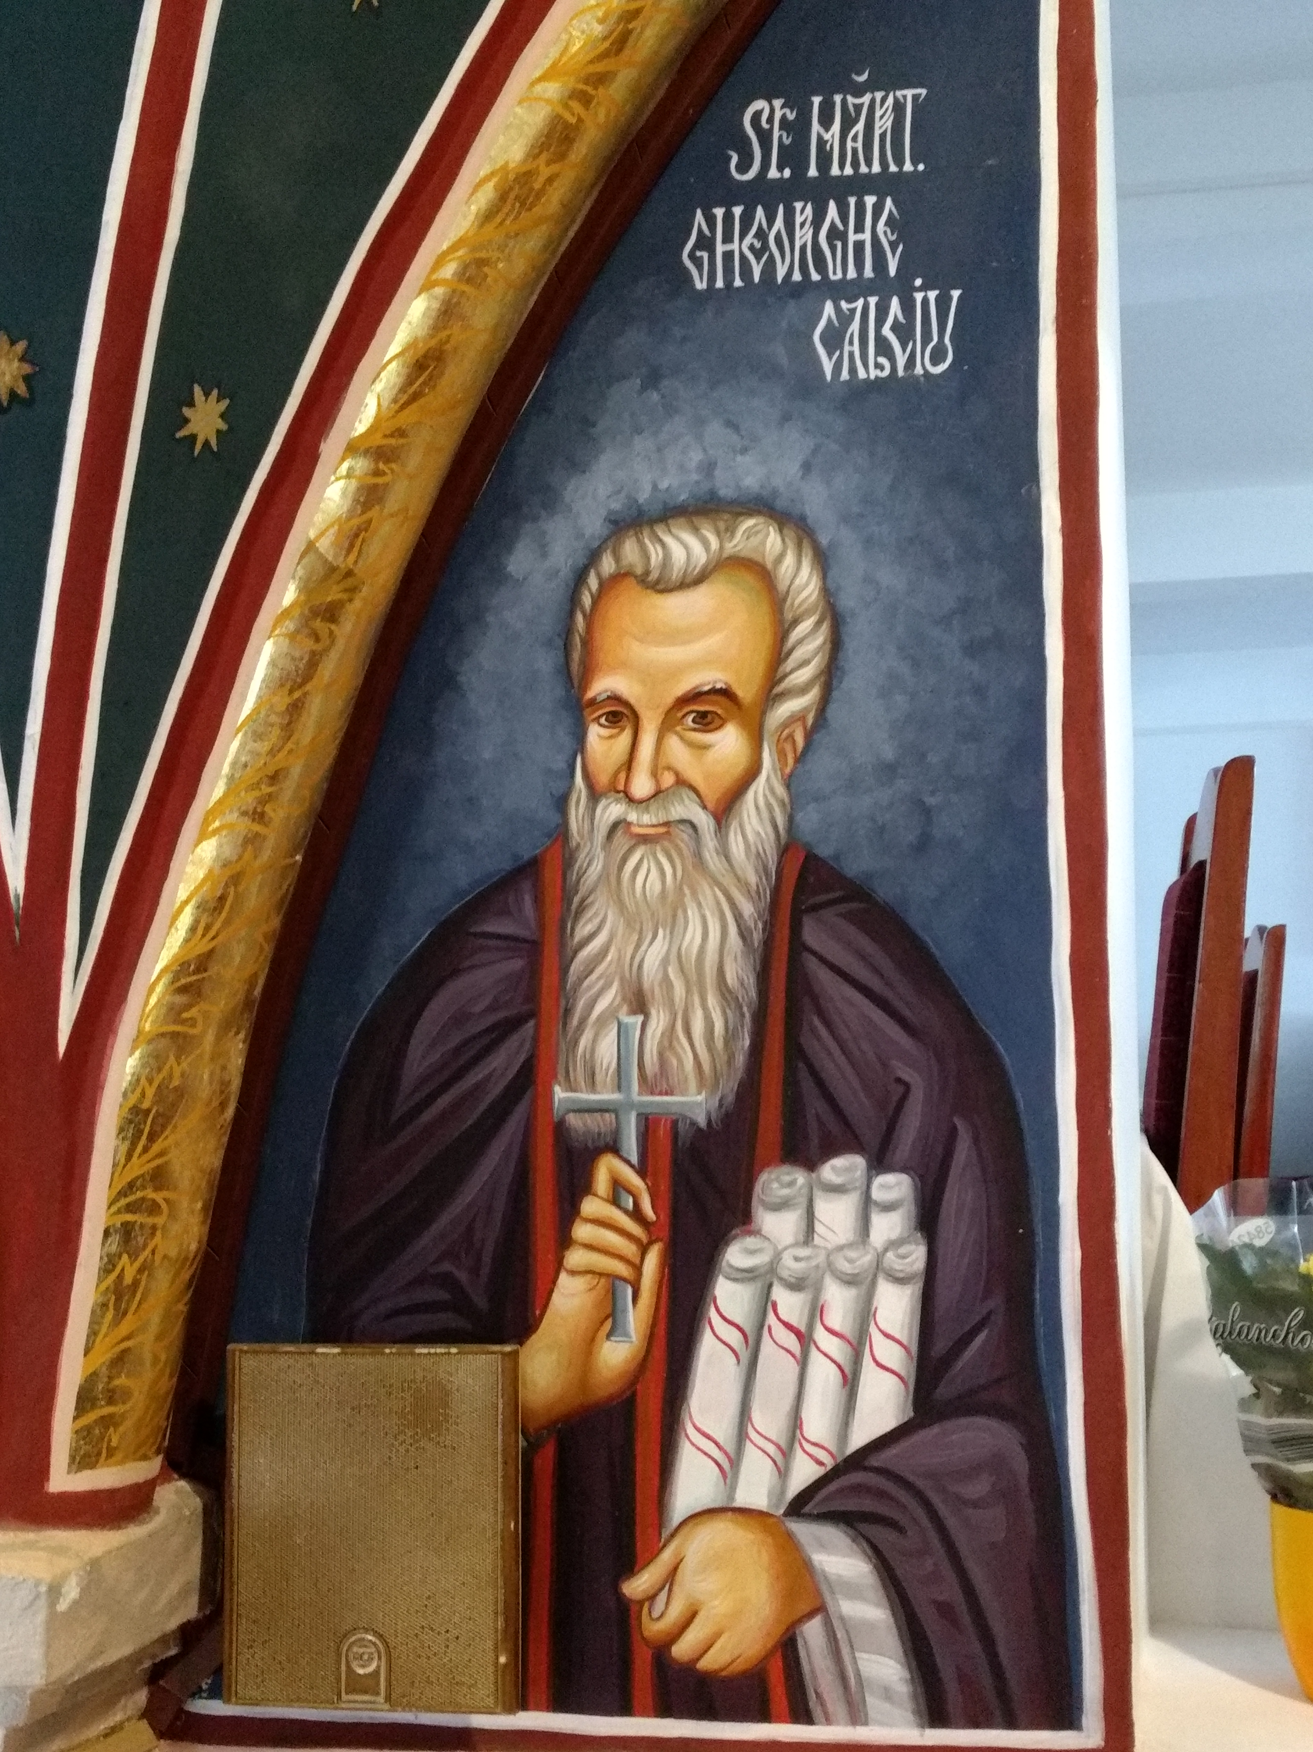  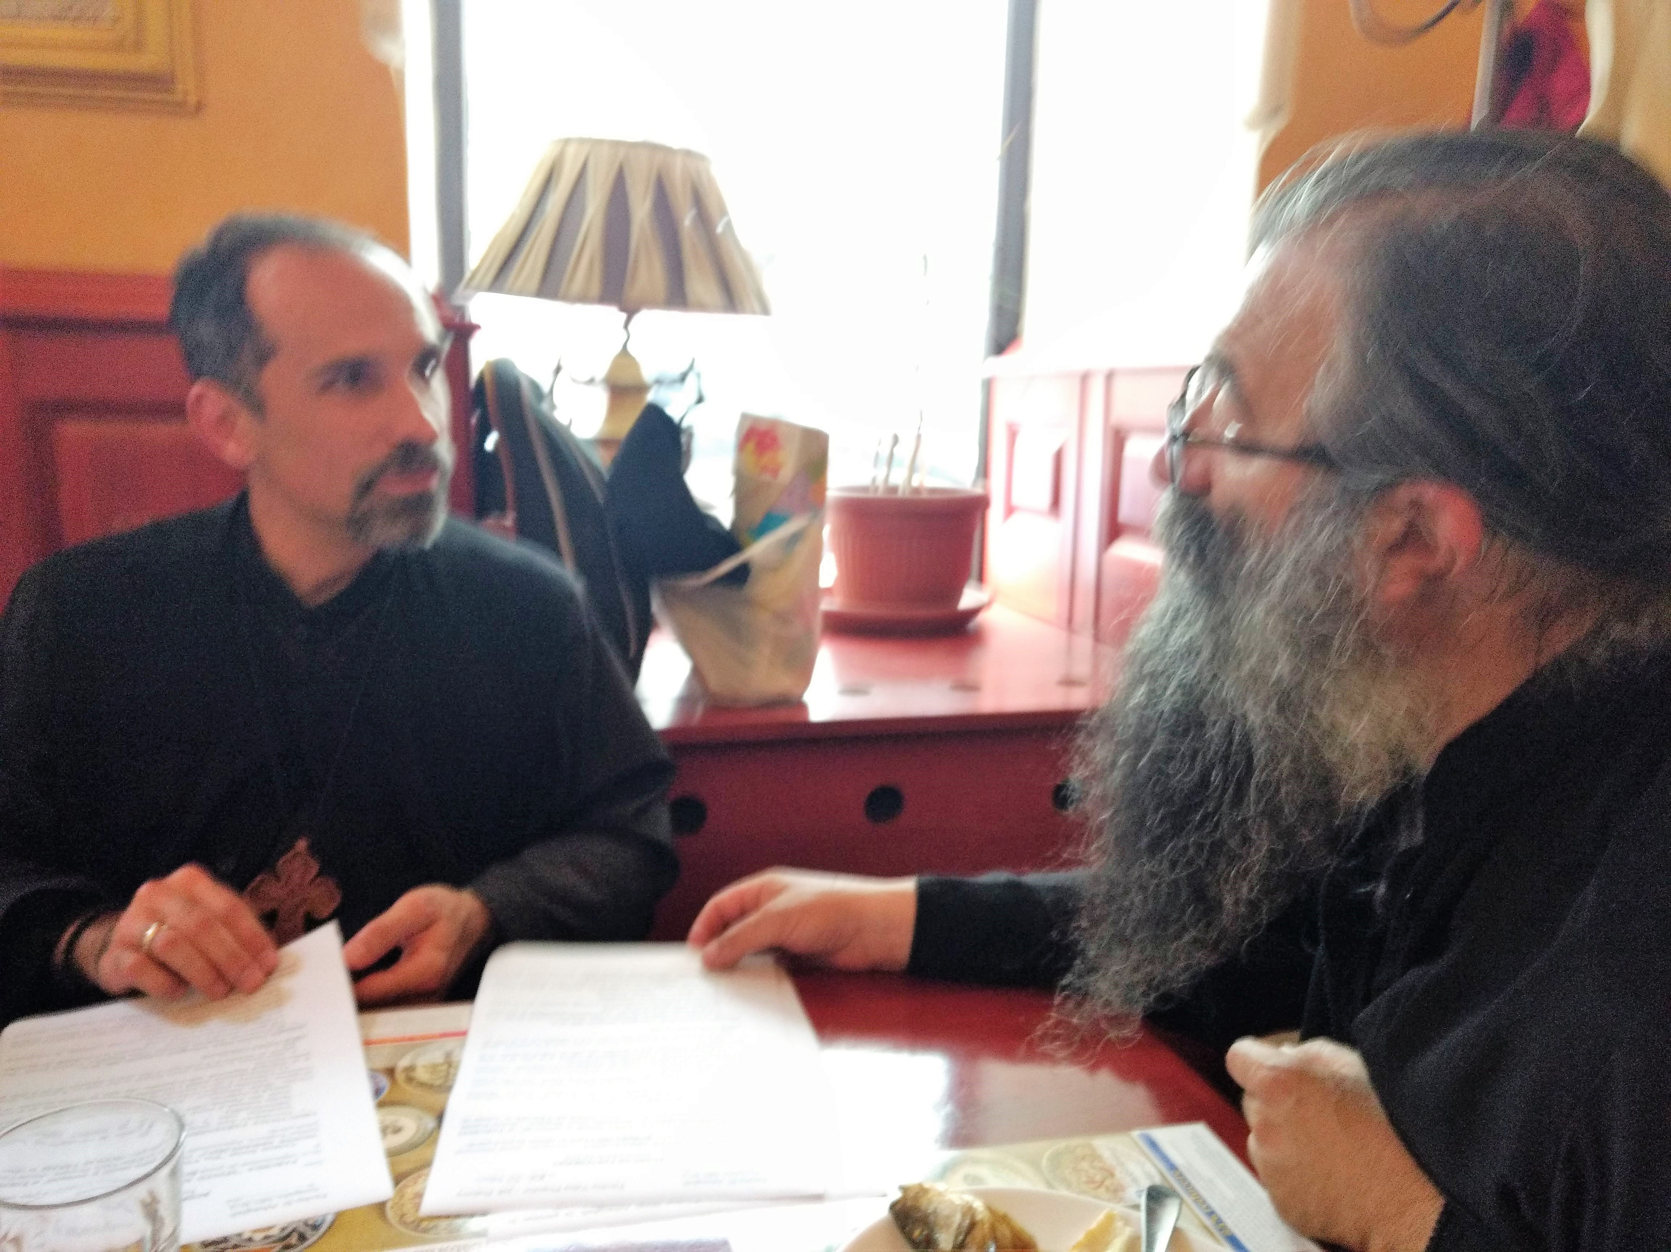 | Holy Archangels Orthodox Church  1353 Tydings Rd., Annapolis, MD 21409  262-844-2369  Fr.RobertMiclean@gmail.com  www.OrthodoxAnnapolis.org | “Spiritual treasures  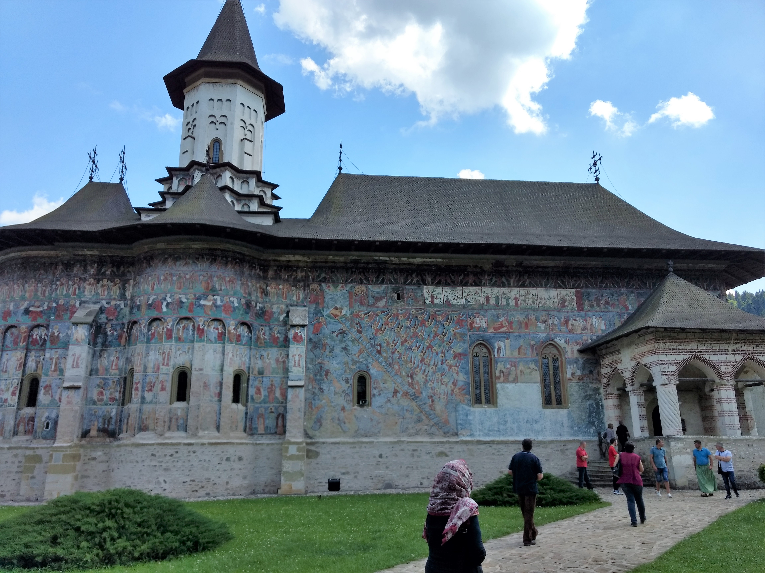  of Orthodox Romania 5.0”—  A Unique Pilgrimage—  10-26 May 2022  “Where your treasure is, there will your heart be also” (Matt 6:21). Holy Archangels Orthodox Mission in Annapolis, MD is offering a unique pilgrimage to all those desiring to strengthen their faith in Christ and see and experience the riches of the spiritual legacy of the Orthodox Church in Romania.

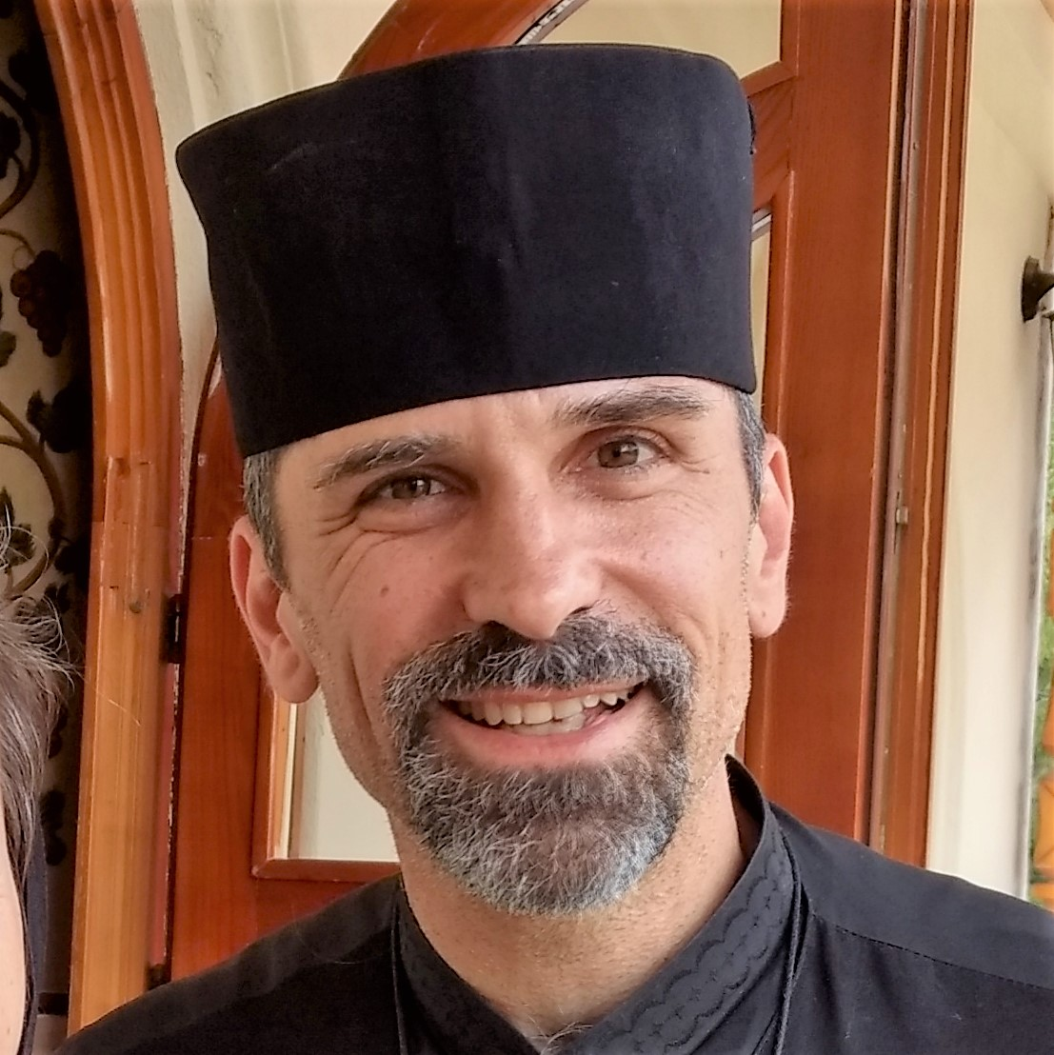  The Pilgrimage Leader  The Rev. Fr. Robert Miclean is pastor of Holy Archangels Orthodox Church in Annapolis, MD and is OCF Chaplain at the U.S. Naval Academy and St. John’s College, where he has served for seventeen years. Fr. Robert has led numerous pilgrimages to Romania, the land of his forefathers, and enjoys sharing with others the riches of Romanian Orthodox spirituality and helping all to grow in the love of Christ. He, his wife and six children live in Annapolis, MD.  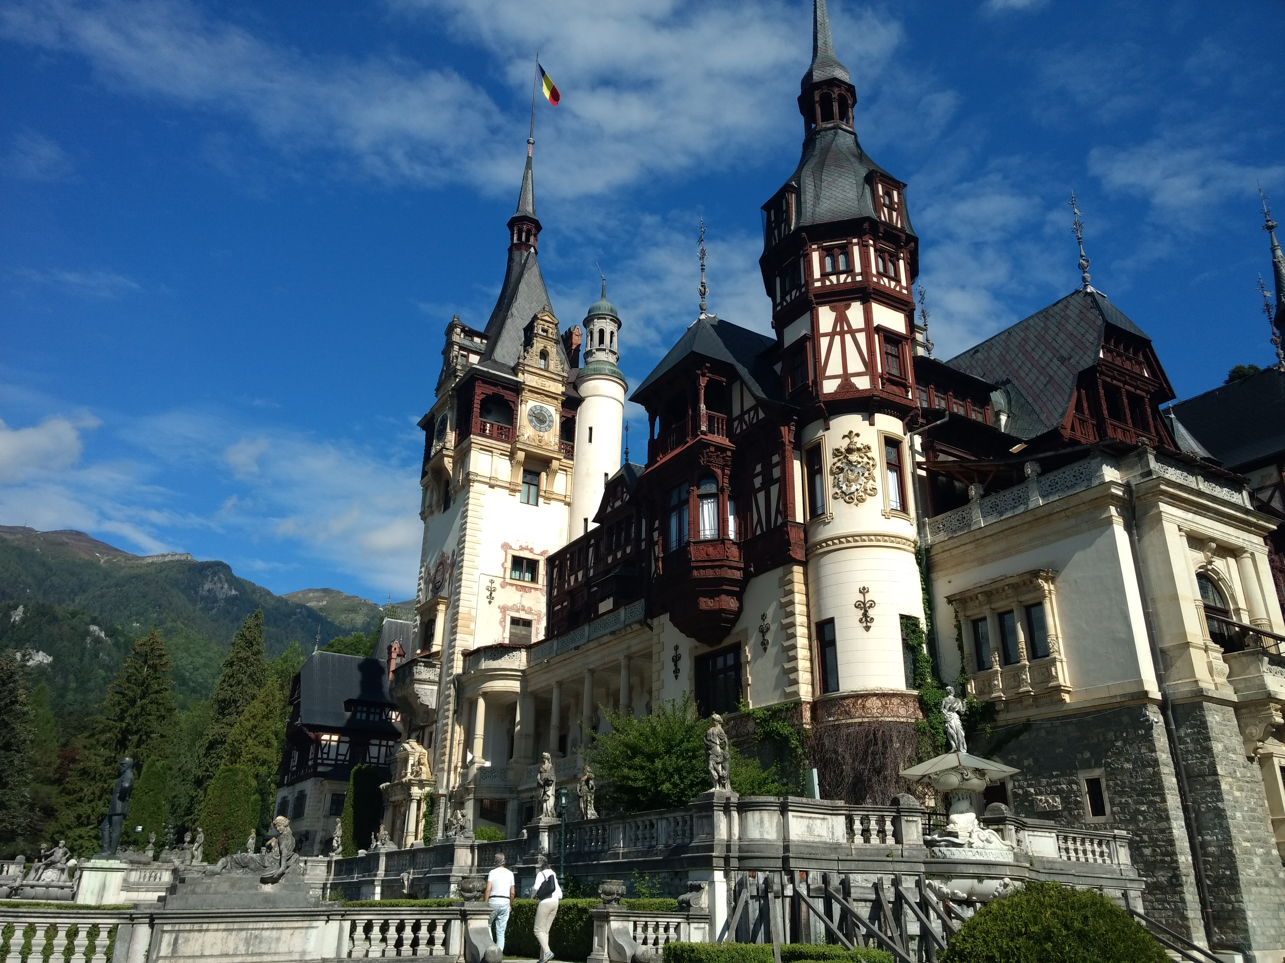 | Be Refreshed in Christ and the Holy Orthodox Faith  Focus more on Christ and grow in faith. Be inspired by the Romanian people and their Saints. Visit some of the most beautiful churches, monasteries in the world. Experience Romanian hospitality, learn to love more as Christ loves, Venerate the relics of the Saints and numerous wonder-working icons. Be emboldened to witness to the truth of Christ upon your return.  Dates: Tue., 10 May–Thur., 26 May 2022  Cost: $3,100/person, $2,800 for accompanying spouse/child, assumes double-occupancy and is valid for registrations received by 7 March (“Clean Monday”) with a $1,000 deposit to hold a space (non-refundable thereafter). Limit: first 7 to register. 2nd part of pymt. due by 25 March (Annunciation) 3rd part by 16 Apr. (Lazarus Sat.). Pymt made by Paypal via our website, pilgrimage tab (OrthodoxAnnapolis.org).  Departure/Return: Dulles Int’l Airport, Washington, D.C. .  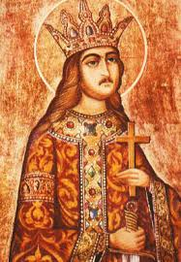  *Included: Int’l Airfare to/fro Dulles, great meals, accommodations in Romania, transportation, experienced pilgrimage leader.  1 St. Stephen the Great of Moldova  Not included: Domestic airfare to/fro Dulles, airport food, tips, personal items you wish to purchase on the trip.  Important: Pilgrims must be in good health, able to walk reasonable distances (3-4 miles/day) and adhere to the teachings of the Orthodox Church. | Highlights  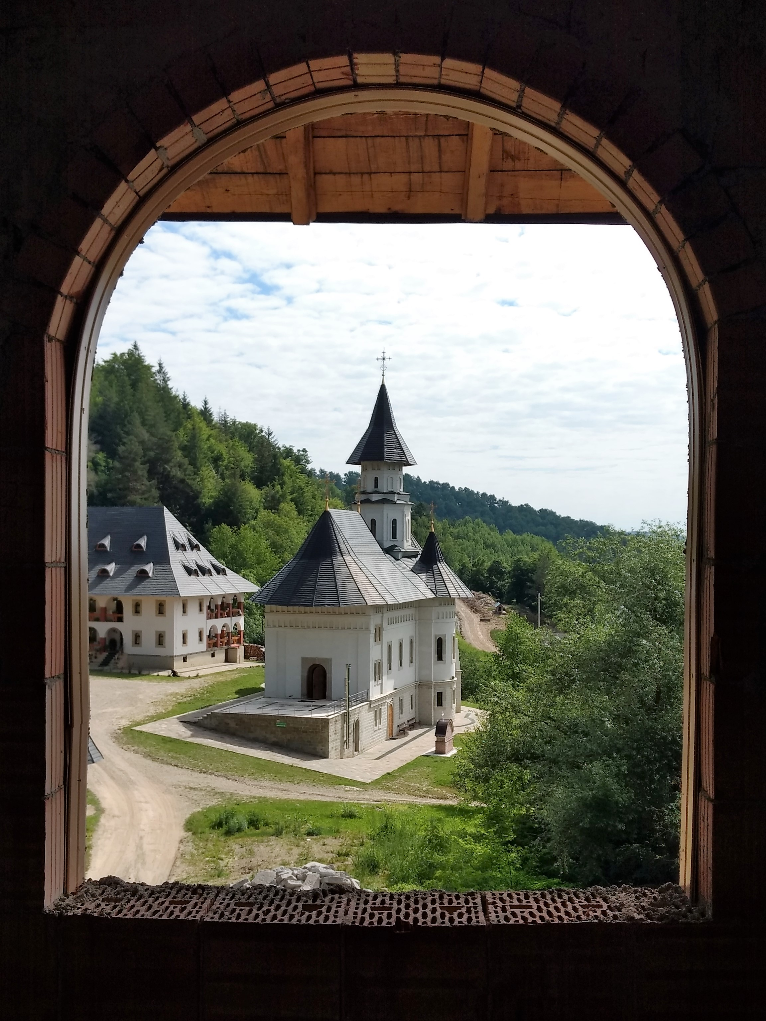  We arrive in Bucharest, travel to the unique ProVita orphanage and ministry begun by Fr. Nicolae Tanase, home to over 300 children. We visit the holy monastery of Crasna nestled in the beautiful foothills of the Carpathian Mountains, journey to the breathtaking mountain town of Sinaia and Peleş Castle, home to the kings of Romania. From there we head north to the regions of Moldova and Bucovina to visit the holy monasteries of Bistrita, Pangarati, Petru Voda, resting place of Fr. George Calciu, Sihastrie, resting place of Elder Cleopa, and Agapia, followed by the world-renowned painted monasteries Putna, resting place of St. Stephen the Great, Voroneţ, Moldoviţa, and Suceviţa—all UNESCU World Heritage Sites. We return to Bucharest for our final days and the Great Feast of Ascension, visit St. Nicholas (the ‘Russian’ church of the University, built by Czar Nicholas II, Antim Monastery, home to the “Burning Bush” movement that prepared the Church for Communist persecution, venerate the hand of St. Nicholas, the relics of St. Spiridon, St. Dimitrie the New, and many other Saints. We will venerate at the Patriarchal Cathedral and the new Cathedral (just completed).

