Father Robert Miclean
Holy Archangels Orthodox Church
September 28, 2016

Exploratory Bible Study on the Acts of the Apostles:
“The Book of Acts through the Eyes of the Early Christians”

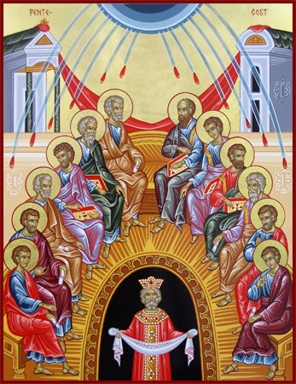
Bible Study #16

Review from last week (Chapter 14-15):

Q: Why did the ordination of “elders” (presbyters = priests) become necessary?

Q: What was the objection by the believers among the Pharisees to the news about the Gentiles presented by Saints Paul and Barnabas?
But the Scripture has confined all under sin, that the promise by faith in Jesus Christ might be given to those who believe. ²³ But before faith came, we were kept under guard by the law, kept for the faith which would afterward be revealed. ²⁴ Therefore the law was our tutor to bring us to Christ, that we might be justified by faith. ²⁵ But after faith has come, we are no longer under a tutor.²⁶ For you are all sons of God through faith in Christ Jesus. ²⁷ For as many of you as were baptized into Christ have put on Christ. ²⁸ There is neither Jew nor Greek, there is neither slave nor free, there is neither male nor female; for you are all one in Christ Jesus. (Gal. 3:22b-28)

Q: How do the Apostles respond to this objection?

Q: What is the example and precedence given at the Council of Jerusalem with regard to settling disputes in the Church? What are the three-fold stages through which the Council moves?

Read Acts 15:36-16:15

Q: What does the “sharp” disagreement between Saints Paul and Silas reveal? How does God even redeem this for the sake of the Gospel?

“And how is it not amiss that upon such a small matter there should arise so great an evil? IN the first place, no evil did come of it… but a great good. And besides, they would not readily have chosen to leave each other… If the exasperation were in seeking their own, and contending for their own honor, this might well be reproved; but both wishing to instruct and teach, one took this way and the other that, what fault can we find?” (St. John Chrysostom, Homily XXXIV on Acts XV in The Bible and the Holy Fathers for Orthodox, p. 96f)

Q: Did St. Paul do wrong in circumcising Timothy (Acts 16:3)? What does this act on the heels of the Council of Jerusalem reveal about the Christian Faith?

Q: What important detail do we learn in verse 10?

Q: What is significant in St. Paul’s calling and evangelism in Europe? How does he evangelize?
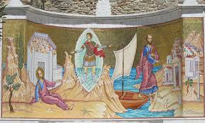
Q: What can we in the Orthodox Church today
learn from St. Paul’s missionary example?

Q: What is important about the first convert to Christianity in Europe? How does God work through her and what is significant about her conversion?

Read Acts 16:16-40

Q: Why do you suspect St. Paul is “annoyed” in verse 18? Why does he cast out the evil spirit that possessed the slave girl?

Q: What is the real reason behind the arrest of the Apostles? What are the three evils committed by the slave girl’s masters?

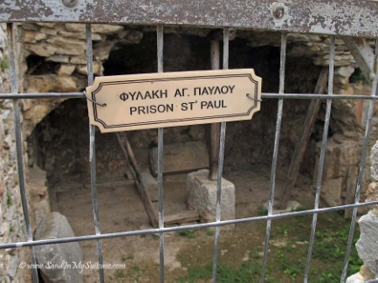
“What could equal these souls? These men had been scourged, had received many stripes; they had been misused, were in peril of their lives, were thrust into the inner prios, and set fast in the stocks: and for all this they did not suffer themselves to sleep, but kept vigil all night.” (St. John Chrysostom, Homily XXXVI on Acts XVI in The Bible and the Holy Fathers for Orthodox, p. 98)

Q: How do the Apostles react to being thrown into prison and shackled for the sake of the truth of the Gospel? What can we learn through the example of the Apostles?

Q: What evidence is there that this earthquake was not just a coincidence?

Q: What accounts for the jailer’s immediate question in verse 30, “Sirs, what must I do to be saved?”

Q: What is their response? What must the keeper of the jail do to be saved?

“The faith of the jailer was a voice in itself. What could be equal to this? He is put in bonds, and looses, being bound. He looses a twofold bond: him who bound him he looses by being unbound. These are indeed works of grace.” (Ibid.)

Q: How does St. Paul use (and not use) his Roman citizenship here (vv. 35-40)?

Next Week: Chapter 17: The Church in Thessalonica, Berea, and Athens

