Father Robert Miclean
Holy Archangels Orthodox Church
August 17, 2016

Exploratory Bible Study on the Acts of the Apostles:
“The Book of Acts through the Eyes of the Early Christians”

Bible Study #10
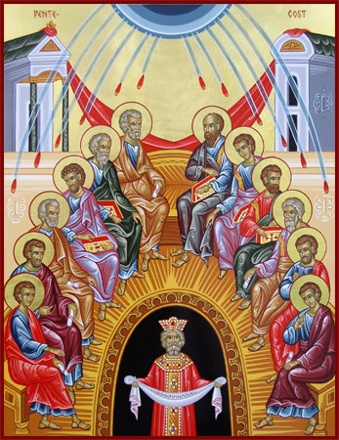
Review from last week (Chapter 8):

Q: How did God take the evil that Saul was doing in persecuting the Church and turn it into something redemptive?

“Preserve the good by Thy goodness and make the evil be good by Thy goodness.”—Liturgy of St. Basil

Q: Why are Saints Peter and John sent to Samaria following Philip’s evangelistic work? Why is this important and what do we learn here about authority in the Church ?

Q: How is the Ethiopian limited in his ability to understand the prophet Isaiah? What does his answer to Philip’s question indicate?

“Again, the Old Testament is the foundation for proclaiming the Gospel of Jesus Christ (see 2:14-40; 7:1-53). Such is the power of the Old Testament that if anyone ‘would apply himself to the study of the prophets, he would need no miracles.’” (St. John Chrysostom, Orthodox Study Bible, p. 1483).

Q: What is the cooperation with the work of the Holy Spirit demanded of the Eunuch? How does this cooperation continue to be practiced in the life of the Orthodox believer today?

Read Acts 9:

Vocabulary Verse 2: “the Way….” In John 14:6 Jesus proclaims that He is “The Way, the Truth, and the Life,” adding that “no one comes to the Father except through Me.” For this reason, early Christians were called followers of the Way?

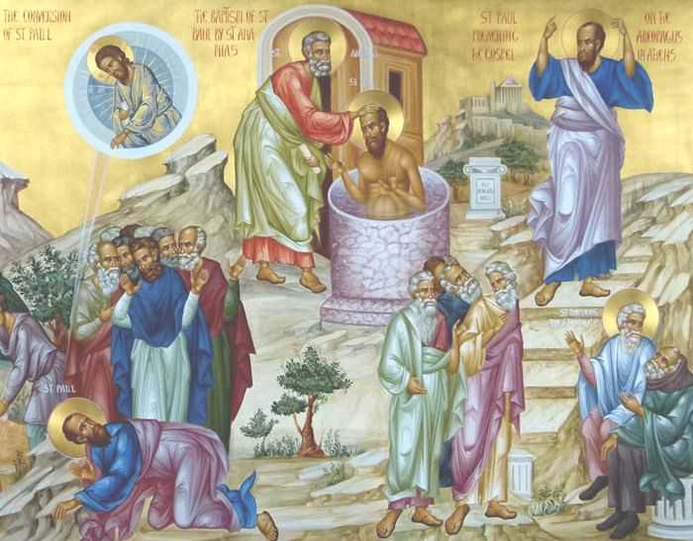
Q: How does this title for our early Christian forbearers inform our understanding of how they saw their new life in Christ?

Q: What does God’s voice to St. Paul reveal about Christ and His relationship to the Church?

Q; What does Christ God mean in saying to Saul, “it is hard for you to kick against the goads”? (See also Acts 5:38-39)

Q: What do you think is the significance of God blinding Saul and for three days? What does it accomplish in his conversion? Why is this necessary? (See also John 9:39)

Q: What is also significant in how Saul receives back his sight?

“The Orthodox Church of Antioch continues an unbroken succession to this early Damascus Church and to this day is headquartered on “the street called Straight” (Acts 9:11).

Q: What evidence is there of a true conversion by Saul?
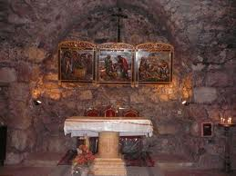

Read Acts 9:19-25

Q: What is the first thing that Saul preached in the synagogues? Why this?

Q: What irony is there in Saul’s life post- conversion?

Read Acts 9:26-31
1 House of Ananias on Straight Street in Damascus

Q: How Barnabas’s action in keeping with what we already know of him (e.g., Acts 4:36-37)?

n.b. Caesarea is located North of Jerusalem along the Mediterranean coast of Israel. Tarsus is today in South-East Turkey. At the time of Christ, these territories were all part of the Roman Empire.

Read Acts 9:32-43

Vocabulary: Verse 31, “Church,” (Gk. = “Ekklesia” from “ek” and “kalio” ‘Those called out [from the world]’.
Verse 32, “saints” (Gk. =haggioi, ‘holy ones’)

Q: What correlation is there between the healings that occurs in verse 34, verse 40, that in vv. 17-18, and in 3:6?

Q: What do these miracles, as those in Mt. 9:22-25, Jn. 11 (raising of Lazarus), reveal about Jesus Christ?

Q: Why does St. Peter put the widows and Saints out before he begins to pray for this miracle?

On the correcting of a sinner before it is too late…
“Mourn, bewail the sinner, and I too will give a loose to tears; I, more than thou, the great the punishment to which he is liable as such: I too will lament, with such an object. But not thou alone must lament him that is such; the whole city must do the same, and all that meet you on the way, as men bewail them that are led to be put to death. For this is a death indeed, an evil death, the death of sinners. But (with you) all is clean reversed.” (St. John Chrysostom, Homily XXI on Acts 9:26,27)

Q: Given what St. John is saying, what should be our motivation and concern for those who are spiritually perishing? If the death of God’s saints makes us weep…

Next Week: Chapter 10, Cornelius’ vision and that of St. Peter, Evangelization of the Gentiles…

