Father Robert Miclean
Holy Archangels Orthodox Church
August 10, 2016

Exploratory Bible Study on the Acts of the Apostles:
“The Book of Acts through the Eyes of the Early Christians”

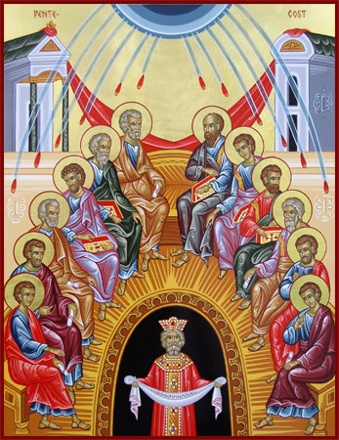
Bible Study #9

Review from last week (Chapter 7):

Q: How would you describe the contrast between the Jewish leaders’ response to St. Stephen’s defense and St. Stephen’s bearing as he is being carried out of the city, then stoned to death?

Q: What similarities do you see in St. Stephen’s death with that of Christ?

Q: What do we learn in these verses about this man, Saul?

Vocabulary:

Chapter 7, Verse 38 “living oracle,” (Gk. = logia zonta, “living divine utterances, declarations from the word, logos and zoe). The “living oracles” refer to the Ten Commandments given to Moses on Mt. Sinai.

Read Acts 8:4-25

Q: How did God take the evil that Saul was leading and turn it into something redemptive?

“Preserve the good by Thy goodness and make the evil be good by Thy goodness.”—Liturgy of St. Basil

Q: How does Philip (one of the Seventy), further the evangelist work begun by St. Photini (see John 4:39)?

Q: What is the blasphemy inherent in what the people believed of Simon?

Q: Why are Saints Peter and John sent to Samaria following Philip’s evangelistic work? Why is this important and what do we learn here about authority in the Church ?

Q: What do we also learn here about Baptism and Chrismation? What is meant by “baptized in the name of the Lord Jesus”?

“Do not imagine that because the names of the Father and the Holy Spirit are sometimes omitted when the Apostle speaks of baptism that the invocation of their names has been omitted… (St. Basil the Great, Orthodox Study Bible, p. 1482)

Q: What is Simon’s sin (verse 19) and his ignorance concerning Chrismation?
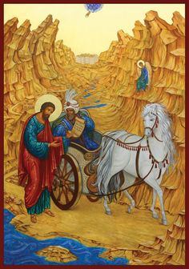
Q: How is Simon restored?

Read Acts 8:26-40

Candace, a Meroitic language term for "queen" or "queen-mother," Fage, John. A History of Africa. Routledge, p. 115. ISBN 1317797272.
.
Q: What do we learn about the Ethiopian eunuch? In what ways is he prepared to receive this revelation?

“High encomiums (enthusiastic praise) for the man, that he, residing in Ethiopia and beset with so much business, and when there was no festival going on, and living in that superstitious city, came ‘to Jerusalem for to worship.’ Great also is his studiousness, that even ‘sitting in his chariot he read.’”—St. John Chrysostom, Homily XIX

Q: How is the Ethiopian limited in his ability to understand the prophet Isaiah? What does his answer to Philip’s question indicate?

Q: How is God’s providence seen in the timing and that which the Ethiopian was reading?

“Observe how it is Providentially ordered. First he reads and does not understand; then he reads the very text in which was the Passion and the Resurrection and the Gift…” (St. John Chrysostom, Homily XIX).

“Again, the Old Testament is the foundation for proclaiming the Gospel of Jesus Christ (see 2:14-40; 7:1-53). Such is the power of the Old Testament that if anyone ‘would apply himself to the study of the prophets, he would need no miracles.’” (St. John Chrysostom, Orthodox Study Bible, p. 1483).

n.b. These words from the Prophet Isaiah (Is 53:7-8) are recited by the priest in preparation of the Holy Lamb during the service of the Proskomedia.

Q: What is the cooperation with the work of the Holy Spirit demanded of the Eunuch? How does this cooperation continue to be practiced in the life of the Orthodox believer to this day?

Next Week: Chapter 9,The Conversion of Saul

