Father Robert Miclean
Holy Archangels Orthodox Church
August 3, 2016

Exploratory Bible Study on the Acts of the Apostles:
“The Book of Acts through the Eyes of the Early Christians”

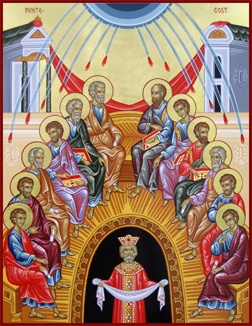
Bible Study #8

Review from last week (Chapter 6):

Q: Describe the synergy (Gk. sunergos) we see here between the laity and the Apostles (clergy)?
Q: What can we learn from the way in which the Apostles and the people responded to the challenge that faced them regarding the distribution? How does this relate to contemporary problems that a church might face?
Q: What part can each of us play in building up the Church as a whole (look back once again at I Cor. 12)?
Q: How can we further support the work of building the Church and “spreading the word of God” in our own area?
Q: What brought St. Stephen into ill will with the Freedmen? Of the charges levied, what is true?

“Do not think that I came to destroy the Law or the Prophets. I did not come to destroy but to fulfill.” (Matt. 5:17)

Read Acts 7:1-53
St. Stephen’s Defense

Q: How would you summarize St. Stephen’s defense against the Jewish leaders?

Q: What is the pivotal point of his defense?

Q: What is his indictment against his fellow Jews?

n.b. Verses 38-43 “…Whom our fathers would not obey, but rejected.” This rejection is first noted in Exodus 20:19 after Moses had come down with the 10 Commandments from Mt. Horeb and is related in Deut. 18:15 (below).

v. 37 Deuteronomy 18:15—“The Lord your God will raise up for you a Prophet like me from your brethren. Him you shall hear, according to all you asked from the Lord your God in Horeb in the day of the assembly, saying, ‘Let us not hear again the voice of the Lord our God, nor let us see this great fire any more, lest we die.’ Then the Lord said to me, ‘What they have spoken is good. I will raise up for them a Prophet like you from among their brethren, and I will put My word in His mouth, and he shall speak to them all I command Him. Therefore, whatever the Prophet speaks in My name, I will require it of him.’”

Q: Why would God raise up “a prophet like you” (speaking to Moses)? What parallels are there between Moses and Christ? How does Jesus Christ fulfill and perfect the ministry of Moses?

** Jesus Christ is Prophet, Priest, and King:
- He is Prophet in that he fulfills the words spoken by Moses and all the Prophets concerning the Truth of God and His promises of salvation to Israel and the world.
- Christ is the Great High Priest in that through His Incarnation He offers Himself as the Perfect Sacrifice, Who, as the Life of all, defeats death on the cross by His resurrection, and makes possible our own resurrection from the dead. Paradise is reopened, death is slain, and we are endowed with life through Holy Baptism and the Life that is lived in and with Him.
- Christ is King of Kings, Lord of Lords in that at His Second Coming He will judge and defeat evil. He will establish an everlasting peace and His kingdom shall have no end! (Rev. 19:16)

*This section on Christ as Prophet, Priest, and King is paraphrased and shortened from a more extensive article in the Orthodox Study Bible at Deut. 18.

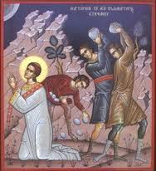
Read Acts 7:54-8:1-4
St. Stephen’s Martyrdom

Q: How would you describe the contrast between the Jewish leaders’ response to St. Stephen’s defense and St. Stephen’s bearing as he is being carried out of the city, then stoned to death?

Q: What similarities do you see in St. Stephen’s death with that of Christ?

Q: What do we learn in these verses about this man, Saul?

Next Week:
Chapter 8—The First General Persecution, The Church in Samaria, the Ethiopian Eunuch

