Father Robert Miclean
Holy Archangels Orthodox Church
August 24, 2016

Exploratory Bible Study on the Acts of the Apostles:
“The Book of Acts through the Eyes of the Early Christians”

Bible Study #11
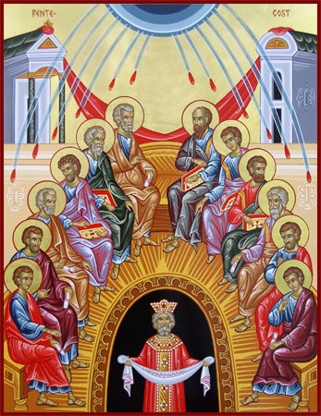
Review from last week (Chapter 9):

Q: The early Orthodox Christians were referred to as followers of “the Way.” What does the use of this term tell us about how our Orthodox forebears saw themselves and what does it continue to teach us about our life in Christ?

Q: What is significant in how Saul is converted?

Q: What do the three miracles of healing, as well as those in Mt. 9:22-25, Jn. 11 (raising of Lazarus), reveal about Jesus Christ as God?

Read Acts 10:1-8
n.b. Joppa was 30 miles (approximately 50 km.) from Caesarea

Q: What three pious attributes characterize Cornelius’ devotion to God?

“See what a great thing prayer is! When he advanced in piety, then the Angel appears to him.” (St. John Chrysostom, Homily XXIII on Acts 10:23-24)

Q: What is telling in the timing of Cornelius’ vision and its affect on him?

Q: What is significant in the angel’s message to Cornelius?

Read Acts 10:9-28

Vocabulary: v. 28 “another nation,” i.e., Gk. = Allophylo (foreign, Gentile, non-Jew)

“What then? (it may be asked) is the man yonder in Persia acceptable to Him? If he be worty, in this regard he is acceptable, that it should be granted him to be brought unto faith. The Eunuch from Ethiopia He overlooked not. … It is not the case, that any (such) ever was overlooked. But what he says is to this effect, that God rejects no man.”

Q: What is significant in how St. Peter receives the vision sent to him by God?

Q: What is meant by the vision?

Q: What is indicated by St. Peter’s response and God’s insistence?

“Do you not perceive that whatever enters a man from outside cannot defile him, because it does not enter his heart but his stomach, and is eliminated, thus purifying all foods? And He said, “What comes out of a man, that defiles a man. For from within, out of the heart of men, proceed evil thoughts, adulteries, fornications, murders, thefts, covetousness, wickedness, deceit, lewdness, an evil eye, blasphemy, pride, foolishness. All these evil things come from within and defile a man.” (Mark 7:18-23)

Q: How is Jesus Christ’s teaching (above) indicative of the introduction of a New Covenant understanding and fulfillment of the Old Covenant dietary laws?

Q: What further evidence of faith do we see here among the Gentiles who fear God?
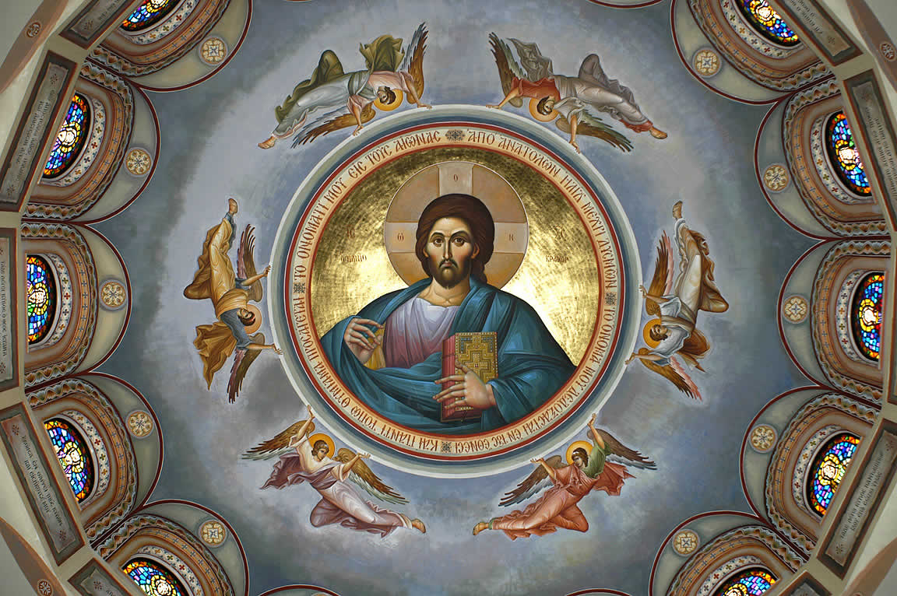
1Christ Pantocrator “Ruler of All”

Read Acts 10: 29-48

Q: What is key in what St. Peter preaches and teaches to Cornelius and his household?

Q: “The promise of God includes both our union with Christ in Holy Baptism and the gift of the Holy Spirit at Chrismation (anointing)” (Orthodox Study Bible article on Chrismation at Acts 2). What is to be understood by the descent of the Holy Spirit prior to Holy Baptism? Why was this astonishing to the Jewish Christian believers?

Q: How does the baptism of Cornelius and his household further complete or fulfill the Prophet Joel’s prophesy (Joel 3:1) that God would pour out His Spirit “upon all flesh”?

Q: How is the truth of Christ’s Incarnation and the Great Commission underscored by Acts 10?

Application:
Q: What application for our own faith and the Orthodox Church today can we take away from this passage?

