Father Robert Miclean
Holy Archangels Orthodox Church
July 20, 2016

Exploratory Bible Study on the Acts of the Apostles:
“The Book of Acts through the Eyes of the Early Christians”
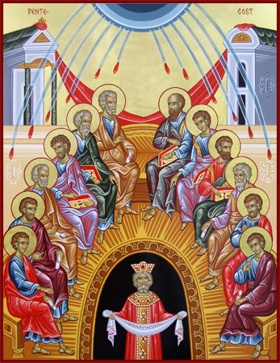
Bible Study #6

Review from Acts 4

Q: What do we learn from the Apostles’ (especially St. Peter’s) example and witness before the Sanhedrin as those living in an age when Christians of true worship are often told to keep their faith ‘private and to themselves’?

Q: What is redemptive for St. Peter in his witness for Christ before the Sanhedrin?

Barnabas vs. Ananias and Sapphira…
Read Acts 4:32-5:11
Q: How would you characterize the life of the early Church as we see it in these verses?

Q: Why is Barnabas held up as a godly example?
What equivalent actions today would likewise build up and further the work of the Church?

Q: What is Annanias and Sapphira’s sin? What are they guilty of?

He that has chosen to sell his goods and distribute them, and then withdraws them, is guilty of sacrilege. But if he is sacrilegious, who resumes from his own, much more he who takes from what is not his own. And do not think that because the consequence is not now the same, the crime will go unpunished. Do you see that this is the charge brought against Ananias, that having made the money sacred, he afterwards secreted it? Couldest thou not, said Peter, after selling thy land, use the proceeds as thine own? Wast thou forbidden? Wherefore after thou hadst promised it? See how at the very beginning, the devil made his attack; in the very midst of such signs and wonders, how this man was hardened!—St. John Chrysostom, Homily XII on Acts iv. 36, 37

Q: What does St. Peter mean when he says, “You have not lied to men but to God”?

Q: What do we learn here about the relationship between God and His Church?

Q: What lesson is there here for members of the Church today?

Read Acts 5:12-16
Vocabulary (Verse 12): “one accord” (Gk. = Omothumadon) “with one mind, by common consent”

Q: What are we to make of the healings that are now taking place, where even the shadow of one of the Apostles falling on the sick is enough to heal?

Q: Readings Acts 19:11-12, how are these healings related?
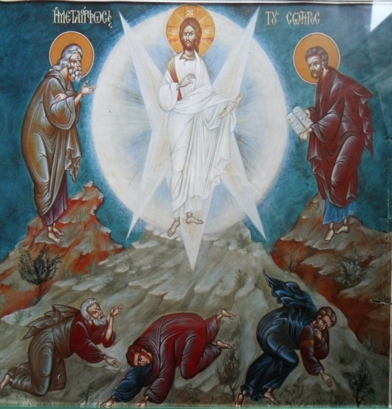
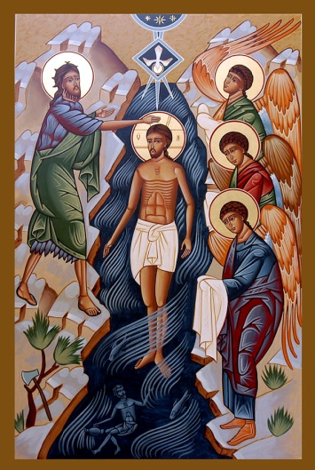
Q: What further truth of God’s redemption through Christ does
it reveal? How does the use of material objects to communicate
God’s grace and healing relate to Theophany (Christ’s Baptism in the Jordan and the manifestation
of the Holy Trinity) and the blessing of the waters, as well as
to the Transfiguration and
the Orthodox practice of blessing fruit at this Feast?

Read Acts 5:17-42
Q: How does the Apostles’ reaction to the latest threats of the high priest and the Sadducees compare with their past response?

Q: What does the reaction of the chief priests following the miracle in the prison indicate?

Note: Verse 30 “hanging on a tree…” “Christ’s Cross is often referred to as a tree, both because it is made of wood and because trees were often used to crucify criminals. There is also a deeper meaning in this term, for just as a living tree brought death to mankind through Adam (Gn. 2:17), now a dead tree brings life to mankind through Jesus.” (Orthodox Study Bible)

3rd Century St. Irenaeus on Christ’s Recapitulation…
“So the Lord now manifestly came to His own, and, born by His own created order which He Himself bears, He by His obedience on the tree renewed [and reversed] what was done by disobedience in [connection with] a tree…” (St. Irenaeus, Book V, Against Heresies in Cyril C. Richardson, Early Christian Fathers, 1996).

Vocabulary: Verse 31, “Repent” (Gk. = μετανοia) change of heart, change of way, conversion.

Q: What is significant (again) in the Apostles’ response to the chief priests?

Q: What is striking in the chief priests’ response to Gamaliel, what they then do to the Apostles?

Application:
- We do not currently face arrest and beating for the sake of our faith in Christ, yet many Christians today fear making the sign of the cross or praying in public or standing for the truth. What does the witness of the Apostles in Chapters 4-5 have to say to us in this regard?

- How can we ensure that our giving to the Church is as Barnabas, not as Ananias and Sapphira?

Coming Up: The first Deacons ordained, Evangelism spreads, St. Stephen is martyred and the first general persecution begins.

