Father Robert Miclean
Holy Archangels Orthodox Church
September 21, 2016

Exploratory Bible Study on the Acts of the Apostles:
“The Book of Acts through the Eyes of the Early Christians”
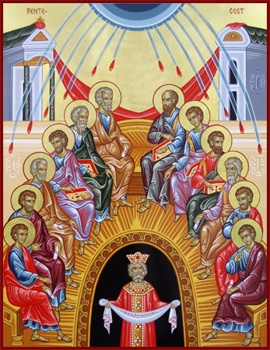
Bible Study #15

Review from last week (Chapter 13):

“This was no small thing that the Christ should be from David… On all occasions we find them making a great point of showing this, that the blessing is peculiarly theirs, that they may not flee from Christ…” (St. John Chrysostom, Homily XXIX on Acts XIII).

Q: What is the critical argument of St. Paul in this his first sermon (Acts 13)?

“For the Law, having a shadow of the good things to come, and not the very image of the things, can never with these same sacrifices, which they offer continually year by year, make those who approach perfect. For then would they not have ceased to be offered? For the worshipers, once purified, would have had no more consciousness of sins. But in those sacrifices there is a reminder of sins every year. For it is not possible that the blood of bulls and goats could take away sins. Therefore, when He came into the world, He said: ‘Sacrifice and offering You did not desire, but a body You have prepared for Me’ (from Psalm 40:6)… we have been sanctified through the offering of the body of Jesus Christ once for all.” (Hebrews 10:1-4, 10)

About the Law:
- “Although Old Testament sacrifices prefigured Christ’s sacrifice, they were powerless in themselves. An effective sacrifice requires a body…. Prepared (v.5).” (OSB, p. 1665).
- The Law of Moses could not bring about justification (Acts 13:39). The word, “justification” is translated from the Greek word, “dikaiothenai,” = “to acquit, declare and treat as righteous, to be set free from God’s judgment.”
- Instead, the Law convicted concerning sin, made sin known (Rom. 3;20; 7:7). “Man’s God-given natural law, written in the conscience, was dulled through disobedience in the years between Adam and Moses. The Mosaic Law helped renew this knowledge of sin to lead man to repentance and prepare Him for something better—the gift of Himself for the life of the world, whereby He renews human nature by His incarnation and destroys sin and death by His death and resurrection.
- There is no contradiction between Christ and the Law because Christ, the Logos (Word) of God, is the Author of the Law given to Moses. The presence of Moses and Elijah at the Transfiguration shows Christ as the fulfillment of the Law and the Prophets.
- “Christ is the Incarnate Lawgiver who offers us remission of sins through His precious blood” (and life in Him). “The old Law could never remit sins. Christ not only forgives sins but also heals the damage done through sinning…” (see also OSB, p. 90).

Read Acts 14:1-28

n.b. “Lystra and Derbe, cities of Lycaonia,” verse 6, are located in central Anatolia in Asia Minor. Iconium was the capital.

Q: How would you describe the difference between how the Apostles respond to the cries of the people saying, “the gods have come down to us in the likeness of men!” (Verse 11) and how Harod responded to the same sentiment (Acts 12:20-25)?

Q: How does St. Paul appeal to these Gentile hearers? How does this differ with his appeal to the Jews? What does this reveal?

Q: What accounts for the fickleness of the crowds (difference between 14:18 and 14:19)?

Vocabulary: NKJV “elders” in Verse 23, Gk., presbyteros (priests)
NKJV “appointed” also in Verse 23, Gk. cheirotoneo (xeros = hand) better translated, “having ordained by the laying on of hands”

Q: Why was the ordination of “elders” (presbyters = priests) necessary?

Read Acts 15:1-35
n.b., “Now the apostles and elders (presbyters) came together to consider this matter…” The Council took place in Jerusalem.

Q: What is the larger question at issue here beyond circumcision?

Q: What was the objection by the believers among the Pharisees to the news about the Gentiles presented by Saints Paul and Barnabas?

Q: What is the example that is given here with regard to disputes in the Church?

Q: What is important to note in St. Peter’s testimony? What is his point re. the Law?

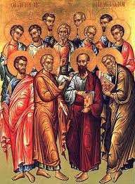
“’By my mouth,’—observe how he shows that it was God speaking through him, and no human utterance… Everywhere he puts the Gentiles on a thorough equality… From faith alone, he says, they obtained the same gifts. This is also meant as a lesson to objectors. It serves to teach even those in whom faith alone is needed, not works nor circumcision…” (St. John Chrysostom, Homily XXXII on Acts XV in The Bible and the Holy Fathers for Orthodox, p. 94).

Q: Who presides at this Council? Why?

“There was no arrogance in the Church… Great was the orderliness of the proceedings. John speaks no word here, no word is spoken by the other Apostles, but they held their peace, for James was invested with the chief rule. And do not think it a hardship. So clean was their soul from love of glory.”

Q: What is the outcome of the Council? Note the three-fold process of the Council, which moves through the stages of a) assembly, v. 6, b) testimony, vv. 7-12, c) decision, vv. 13-21, d) adoption, vv. 22-29).

Q: “it seemed good to the Holy Spirit and to us…” (v. 28) Who is “us” here? What does it mean? Why was the Decree from the Council written down and disseminated?

n.b. Silas is one of the 70 Apostles sent out by Christ to preach (Luke 10:1)

Next Week: Chapters 15:36-41, 16—The Call to Europe, Saints Paul and Silas Imprisoned

