Father Robert Miclean
Holy Archangels Orthodox Church
September 7, 2016

Exploratory Bible Study on the Acts of the Apostles:
“The Book of Acts through the Eyes of the Early Christians”

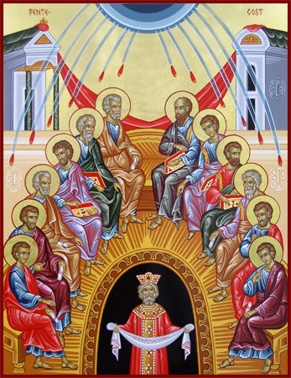
Bible Study #13

Review from last week (Chapter 11):

Q: Why does St. Peter emphasize what he does in relating to his fellow Jewish Christians the conversion of Cornelius and his household? Why is St. Peter’s message received as it is?

Q: What do we learn about order in the early Church in St. Barnabas being sent to Antioch by the Church in Jerusalem?

Q: What is important about the Church’s response to the needs of the Jewish Christians in Judea?

Read Acts 12:1-19
n.b. “Herod Agrippa is the grandson of Herod the Great, who tried to kill Jesus as an infant (Mt. 2:16). Herod Agrippa ruled as king in Palestine under Rome in AD 41-44.” (OSB)

n.b. 2 Verse 2, “James the brother of John,” St. James the Greater, elder son of Zebedee, first Apostle to be martyred.

Vocabulary: “squad” verse 4—there are between 8-14 soldiers in a squad.

Q: What does it mean that the Church is now persecuted to the point that some of the Apostles and others are being martyred for their faith in Christ?

Q: How does God work through the intercessory prayers of the Church?

For as many as are led by the Spirit of God, these are sons of God. ¹⁵ For you did not receive the spirit of bondage again to fear, but you received the Spirit of adoption by whom we cry out, “Abba, Father.” ¹⁶ The Spirit Himself bears witness with our spirit that we are children of God, ¹⁷ and if children, then heirs—heirs of God and joint heirs with Christ, if indeed we suffer with Him, that we may also be glorified together. (Rom. 8:14-17)

Q: What is remarkable and note-worthy regarding God’s provision for St. Peter here?

“‘All of them, with one accord,’ says Scripture, ‘joined in constant prayer together with the women and Mary, the mother of Jesus, and His brothers.’ They kept praying with one mind, demonstrating both their perseverance and their unity in prayer. For God, who enables people of one mind to dwell peaceably under one roof, will admit into His heavenly, eternal home only those who are of one mind in prayer.” (St. Cyprian of Carthage on The Lord’s Prayer in The Bible and the Holy Fathers for Orthodox, p. 86.)

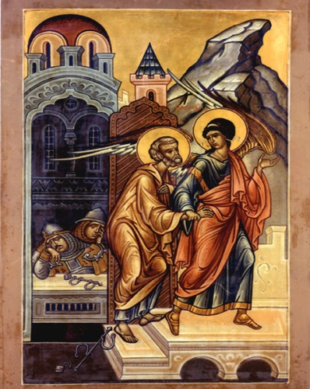
Q: What example of prayer do we find among the
Christians in Jerusalem?

Read Acts 12:20-25

Q: Why do you think Herod is made an example of? What is his great sin?

Q: What do we make of the contrast between Herod’s death and the Church’s growth?

Read Acts 13:1-12

Vocabulary: “ministered” (verse 2) = Gk. leitourgounton (liturgical ministrations, performing liturgical acts)

“Liturgical worship did not originate in Antioch. Its roots are in ancient Israel. Saul and Barnabas, who came from Jerusaelm, taught the Antiochian Christians—among other things—true worship (11:22-26).”—Orthodox Study Bible, p. 1491

Q: Why is it important to note that the Apostles were leading the faithful in liturgical worship? Why is this important for the Early Church, why is it important for the Church today?

“The Lord said to him, ‘Go, for he is a chosen vessel of Mine to bear My name before Gentiles, kings, and the children of Israel…” (Acts 9:15)

Q: If Saul (Paul) received a direct calling from Christ God, why did he need ordination as we read here (Acts 13: 3)?

n.b. Seleucia was an ancient Greek city on the Mediterranean coast of Pamphylia, in Anatolia, in what is today Turkey (Asia Minor).

n.b. The name, “Saul,” means “prayed, asked for,” while “Paul,” means “little, small.” St. Paul refers to himself as “the least of the Apostles.” (Eph. 3:8, I Cor. 15:9).

“Here his name is changed at the same time that he is ordained, as it was in Peter’s case…” (St. John Chrysostom, Homily XXVII on Acts XIII)

Q: What teaching and example is there here for us when we consider Saul’s change to Paul and the entirety of his conversion?

Q: What is significant in St. Paul’s condemnation of Elymas (Bar-Jesus)?

Next week: Chapter 13 continued: St. Paul’s Sermon in the Synagogue, Evangelism and the Growth of the Church among the Gentiles

