Father Robert Miclean
Holy Archangels Orthodox Church
July 27, 2016

Exploratory Bible Study on the Acts of the Apostles:
“The Book of Acts through the Eyes of the Early Christians”
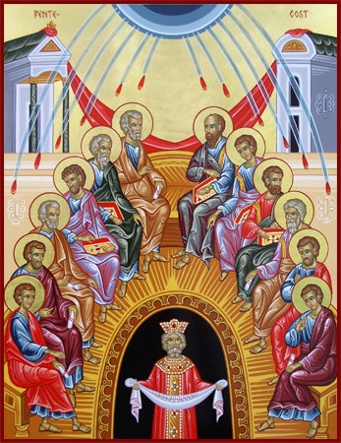
Bible Study #7

Review from last week…
Q: Why is Barnabas held up as a godly example?

Q: What is Annanias and Sapphira’s sin?

Q: What does St. Peter mean when he says, “You have not lied to men but to God”? What do we learn here about the relationship between God and His Church?

Q: How can we ensure that our giving to the Church is as Barnabas, not as Ananias and Sapphira?

Q: What does it mean that healings that are now taking place where even the shadow of one of the Apostles falling on the sick can heal?

Read Acts 5:17-42
Q: How does the Apostles’ reaction to the latest threats of the high priest and the Sadducees compare with their past response?

Q: What does the reaction of the chief priests following the miracle in the prison indicate?

Note: Verse 30 “hanging on a tree…” “Christ’s Cross is often referred to as a tree, both because it is made of wood and because trees were often used to crucify criminals. There is also a deeper meaning in this term, for just as a living tree brought death to mankind through Adam (Gn. 2:17), now a dead tree brings life to mankind through Jesus.” (Orthodox Study Bible)

3rd Century St. Irenaeus on Christ’s Recapitulation…
“So the Lord now manifestly came to His own, and, born by His own created order which He Himself bears, He by His obedience on the tree renewed [and reversed] what was done by disobedience in [connection with] a tree…” (St. Irenaeus, Book V, Against Heresies in Cyril C. Richardson, Early Christian Fathers, 1996).

Q: What is significant (again) in the Apostles’ response to the chief priests?

Q: What is striking in the chief priests’ response to Gamaliel, what they then do to the Apostles? What does this action reveal?

Application:
- We do not currently face arrest and beating for the sake of our faith in Christ, yet many Christians today fear making the sign of the cross or praying in public or standing for the truth. What does the witness of the Apostles in Chapters 4-5 have to say to us in this regard?

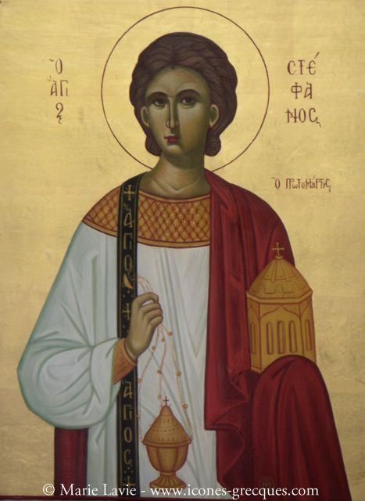
Read Chapter 6 The First Deacons Ordained

Vocabulary: a) ministration/distribution (v. 1) = “diakonia” = “service, ministry, contribution…”
- Hebrews = Jewish Christians who spoke Aramaic (the language of Christ and the Apostles)
- Hellenists = Jewish Christians of the diaspora who spoke Greek as their main language.
- “laid their hands on them,” (v. 6) i.e., to ordain—place their hands on their heads.

Q: How do the faithful respond to the disagreement they are having?

Q: How do the Apostles respond?

- The people (laity) identify a problem affecting unity and good ministry of the Church;
- Recognizing the problem, the Apostles summon the people (laity);
- The laity are charged with identifying those who will help address this problem, based on criteria the Apostles stipulate (v. 3: “good reputation, full of the Holy Spirit, wisdom”).
- The laity choose; the Apostles ordain.

Q: Describe the synergy (Gk. sunergos) we see here between the laity and the Apostles (clergy)? What example does this synergy provide as to the way the Church can grow and adapt?

Q: How does this synergistic model between the clergy and the laity provide an ideal way for the Church to provide for the needs of the ministry?

I Corinthians 12: 24b-26
“But God composed the body, having given greater honor to that part which lacks it, ²⁵ that there should be no schism in the body, but that the members should have the same care for one another. ²⁶ And if one member suffers, all the members suffer with it; or if one member is honored, all the members rejoice with it.²⁷ Now you are the body of Christ, and members individually.”
Ephesians 4:11-13
“And He Himself gave some to be apostles, some prophets, some evangelists, and some pastors and teachers for the equipping of the saints for the work of ministry, for the edifying of the body of Christ till we all come to the unity of the faith and of the knowledge of the Son of God, to a perfect man, to the measure of the stature of the fullness of Christ.”

Q: How does the outcome here in Chapter 6 bespeak the oneness of the Body of Christ?

Q: What brought St. Stephen into ill will with the Freedmen? Of the charges levied, what is true?

“Do not think that I came to destroy the Law or the Prophets. I did not come to destroy but to fulfill.” (Matt. 5:17)

Q: What are we to make of St. Stephen’s face shining “as the face of an angel”?

“The glory of the Law that shone on Moses’ face was to point the Jews to Christ. But their hearts were hard; therefore, they were unable to look upon this glory. The Law was not the problem. The problem was their hardness of heart, which prevented them from seeing Christ in the Law. When, therefore, either a Jew or Gentile now turns to Christ, he sees His glory not only in the Law, but also in the New Covenant.”—St. John Chrysostom, Homily on II Corinthians 3

Next week: Chapter 7, St. Stephen’s Defense and Martyrdom

